**Overview of PROW Permits**

**Outdoor Display Area: $75 annual permit**

Displays must be kept free of graffiti and must not be a hazard to pedestrian traffic (see Illustration V-A for placement restrictions)

Proper displays that are safe and stable with no risk of overturning only; folding tables or cardboard boxes do not qualify

**Allowed** (some maximum quantity limits apply):

-Books, magazines & musical instruments

-Produce, baked goods & food in glass containers

-Cut or live flowers & plants

-Clothing & accessories (on mannequins/hangers – NO RACKS)

-Hand crafted products & goods

-Artwork (paintings, photography, sculpture, frames, pottery

-Sports equipment, bicycles & luggage

-Wooden, metal or patio furniture (NO mattresses or sofas)

-Leather goods & rugs

-Pet accessories (excluding pet food)

-Other merchandise similar in character, type or nature to those listed above with approval from NPMS

**Not Allowed:**

-Alcohol, tobacco, cigarettes or smoking accessories

-Upholstered items with a cumulative height/width/depth of 9+ ft

-Shoes (except those displayed on mannequins or props)

-Vending & dispensing equipment

-Appliances & mattresses

-Canned or prepackaged foods

-Adult-oriented material

-Auto-related merchandise

-DVDs, CDs, videotapes, cassettes etc.

-Computers, home or office electronics

-Cameras and photographic equipment

-Live animals & pet food

-Pawned items

-Weapons (guns, knives, fencing swords, antique pistols etc.)

-Home cleaning products or personal care items

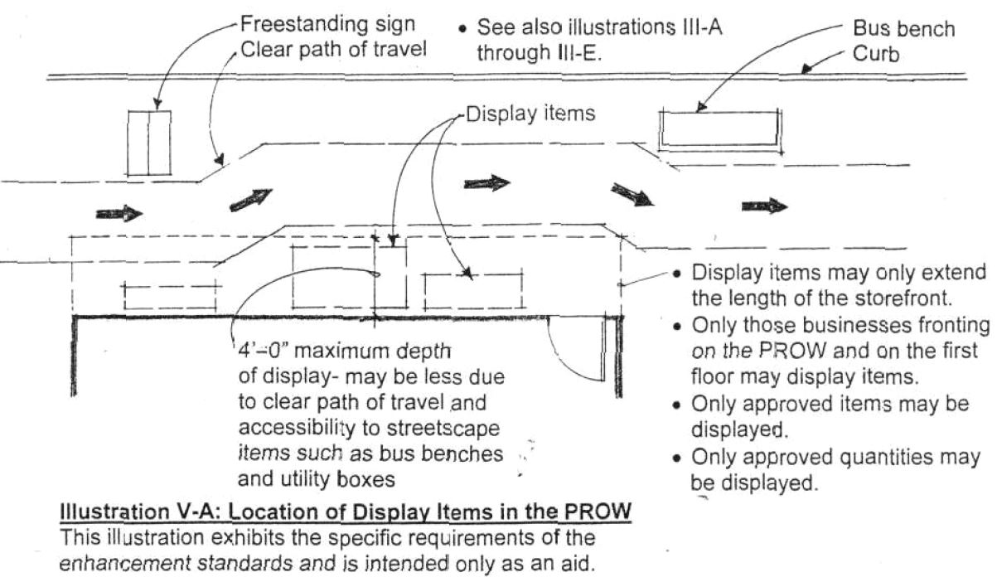

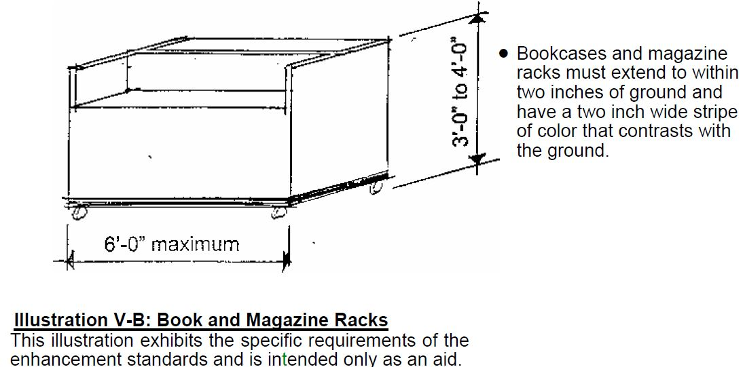

**Freestanding Sign: $50 annual permit**

- Maximum footprint shall be 2’-0” x 3’-0” with a height between 3’-0” and 4’-0”. Signs shall be designed to stand alone, with no more than two faces per sign

- Signs shall be placed in the PROW, but NOT within 2 feet of the curb, in the clear path of travel or in clear areas adjacent to street furniture

- Sign must be placed directly in front of the business it represents. No live advertising is allowed (character actors or staff holding promotional signage)

- Signs shall be brought inside when weather creates potentially hazardous conditions. No glass, breakable material or sharp edges

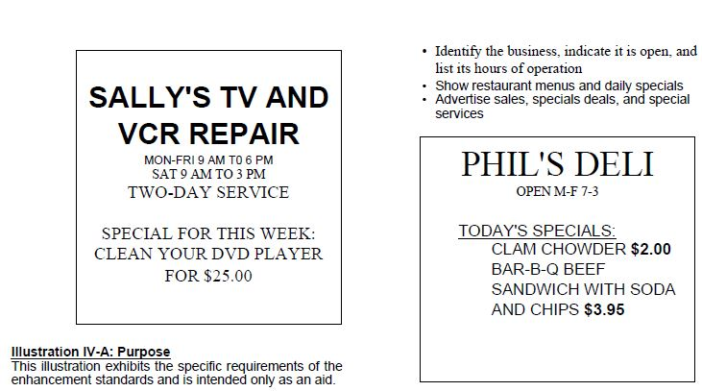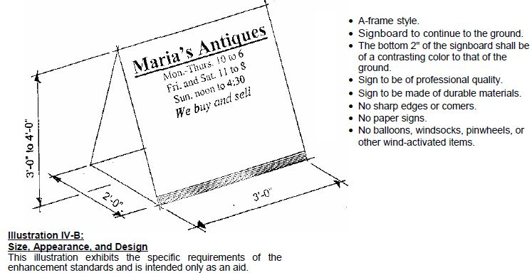

**Outdoor Dining Area: $150 annual permit**

-Sale and consumption of alcohol requires an additional

City of San Diego Sidewalk Café Permit

-Tables and chairs must be in good condition and made of sturdy materials. Umbrellas shall be fire-treated

-Permanent lighting may be added in compliance with City code – lighting must attach to building

-Hours of operation are not to exceed those of the primary use

-May use all of the area in the PROW adjacent to the business except the area required for a clear path for travel or access to street furniture/utility boxes or areas within 2 feet of the curb

(**Exception**: PROW area within 2 feet of curb may be used if parking is head-on rather than parallel)

*Requires submittal of 2 copies of scale drawings of usage boundaries, property lines, existing obstructions, etc.

